Phase-6 project testing

Date | 28-09-2026
Team ID | SWTID-2026-7624
Project name | Script – controlled ACL
Maximum marks | 4 mark

Project Testing
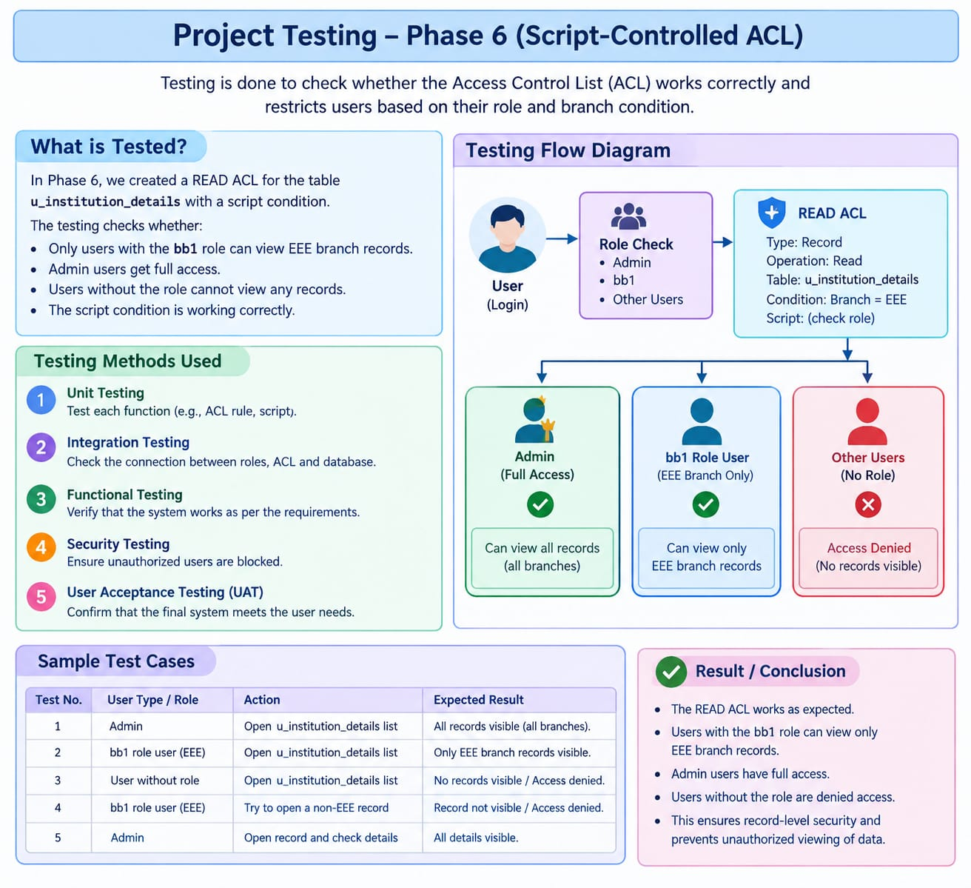
Project testing is performed to check whether the Access Control List (ACL) works correctly and protects the records from unauthorized access. In this project, testing is mainly performed on the READ ACL created for the "u_institution_details" table.

The purpose of testing is to verify that the system allows authorized users to view the required records and prevents unauthorized users from accessing the records.

Testing Process

1. Admin User Testing

The Admin user is tested first because administrators should have full access to the records. The Admin user is impersonated and the "u_institution_details" list is opened.

Expected Result:
The Admin user should be able to view all records, regardless of the branch value.

2. bb1 Role User Testing

A test user with the bb1 role is impersonated and the student records list is opened. The records are checked to verify the branch-based access condition.

Expected Result:
The user with the "bb1" role should be able to view the required EEE branch records.

3. Unauthorized User Testing

A user who does not have the required role is tested by opening the student records list.

Expected Result:
The user without the required role should not be able to view the protected records.

4. ACL Script Testing

The ACL script is tested to verify whether it correctly identifies the user's role and makes the access decision.

The script performs three main checks:

- If the user has the admin role, access is allowed.
- If the user has the bb1 role, access is allowed.
- If the user does not have the required role, access is denied.

ACL Script / Program

(function () {
// Allow admin users full access
if (gs.hasRole('admin')) {
return true;
}

// Allow users with bb1 role
if (gs.hasRole('bb1')) {
return true;
}

// Deny access for all others
return false;
})();

5. Record Verification

Different records are created with different branch values such as ECE, EEE, and CSE. These records are checked using different users to verify whether the ACL is working correctly.

The system is tested by changing the user and checking the records available to that user.

Test Cases

Test Case| User| Action| Expected Result
1| Admin| Open records| All records can be viewed
2| bb1 User| Open records| EEE records can be viewed
3| User without role| Open records| Access is denied
4| bb1 User| Check branch records| EEE branch records are accessible
5| Admin| Check all branches| All branch records are accessible

Expected Result

- Admin: Can view all records.
- bb1 User: Can view the required EEE branch records.
- User without required role: Cannot view the protected records.
- ACL Script: Correctly checks the user's role.
- Record Security: Unauthorized access is prevented.

Conclusion

The testing confirms that the Script-Controlled READ ACL works correctly. The ACL successfully checks the user's role before allowing access. Administrators receive full access, authorized users can access the required records, and users without the required role are denied access. Therefore, the project provides record-level security and helps protect sensitive student information from unauthorized viewing.

